Respiratory Therapist

UPMC Hospitals
Children's Hospital of Pittsburgh of UPMC​  Located in Lawrenceville, Children's Hospital provides infants, children, and  young adults with compassionate, family-centered care.  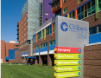Children's Hospital of Pittsburgh  One Children's Hospital Drive  4401 Penn Avenue  Pittsburgh, PA 15224  Phone: 412-692-5325 | ​ | UPMC Montefiore​  UPMC Montefiore, as part of UPMC Presbyterian, is near the University of Pittsburgh in Oakland and delivers a continuum of care for those specialty services offered at UPMC Presbyterian.  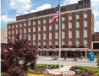UPMC Montefiore  3459 Fifth Avenue  Pittsburgh, PA 15213  Phone: 412-647-2345
​ | ​ | ​
Magee-Womens Hospital​  Magee-Womens Hospital, in Pittsburgh's Oakland neighborhood, offers a full  array of medical and surgical services for both women and men, in addition to obstetric, gynecologic, and neonatal care.​  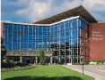Magee-Womens Hospital of UPMC  300 Halket Street  Pittsburgh, PA 15213  Phone: 1-866-MyMagee (696-2433) | ​ | UPMC Northwest​  Situated in Seneca, Pennsylvania, UPMC Northwest is a full-service, acute-care community hospital serving the residents of Venango County and the surrounding region.  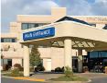UPMC Northwest  100 Fairfield Drive  Seneca, PA 16346  Phone: 814-676-7600
​ | ​ | ​
UPMC Altoona​  UPMC Altoona is a 380-bed acute care hospital with a surgery center and regional trauma center serving Blair and surrounding counties in west-central Pennsylvania.  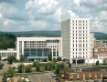UPMC Altoona  620 Howard Avenue  Altoona, PA 16601  Phone: 814-889-2011​ | ​ | UPMC Passavant​  Located in Pittsburgh’s North Hills, UPMC Passavant is a tertiary care center with two convenient campuses in McCandless and Cranberry, PA.​  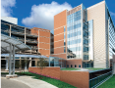UPMC Passavant  9100 Babcock Boulevard  Pittsburgh, PA 15237  Phone: 412-367-6700
​ | ​ | ​
UPMC Bedford Memorial​  UPMC Bedford Memorial is an acute care general hospital with medical,  surgical, obstetrical, intensive care, coronary care, and telemetry units.  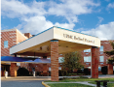UPMC Bedford Memorial  10455 Lincoln Highway  Everett, PA 15537  Phone: 814-623-6161 | ​ | UPMC Presbyterian​  UPMC Presbyterian, in the heart of Oakland, is an adult medical-surgical referral hospital and a site of ongoing research and graduate programs.  UPMC Presbyterian  200 Lothrop Street  Pittsburgh, PA 15213  Phone: 412-647-2345
​ | ​ | ​
UPMC Chautauqua WCA  UPMC Chautauqua WCA, a 317-licensed bed hospital, was chartered in 1885, is Southwestern New York’s largest not-for-profit health care provider, offering an extensive range of inpatient and outpatient acute and rehabilitation services.  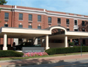UPMC Chautauqua WCA  207 Foote Avenue  Jamestown, NY 14701  Phone: 716-487-0141 |  | UPMC Shadyside​  UPMC Shadyside located in the Pittsburgh neighborhood of Shadyside, is a tertiary-care hospital offering primary medical care, as well as physician and nursing education.  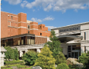UPMC Shadyside  5230 Centre Avenue  Pittsburgh, PA 15232  Phone: 412-623-2121
​ | ​ | ​
UPMC East​  UPMC East, a 156-bed hospital in Monroeville, opened to serve the needs of  our neighbors in the communities east of Pittsburgh.  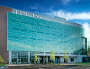UPMC East  2775 Mosside Boulevard  Monroeville, PA 15146  Phone: 412-357-3000 |  | UPMC St. Margaret​  UPMC St. Margaret is a 249-bed acute care and teaching hospital near Aspinwall, PA, serving the residents of northeastern Allegheny County and the Alle-Kiski Valley.  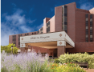UPMC St. Margaret  815 Freeport Road  Pittsburgh, PA 15215  Phone: 412-784-4000​
​ | ​ | ​
UPMC Hamot​  UPMC Hamot is a tertiary-care medical facility serving communities in northwestern Pennsylvania, western New York, and eastern Ohio and is  affiliated with Kane Community Hospital.  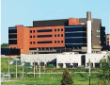UPMC Hamot  201 State Street  Erie, PA 16550  Phone: 814-877-6000 |  | UPMC Susquehanna  UPMC Susquehanna is a four-hospital integrated health system in northern Pennsylvania.  Divine Providence Hospital is a center for outpatient services.  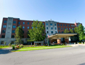Divine Providence Hospital  1100 Grampian Blvd.  Williamsport, PA 17701  Phone: 570-326-8000
​ | ​ | ​
UPMC Horizon​  Comprised of two hospital campuses, Greenville and Shenango Valley,  UPMC Horizon provides a full range of inpatient, outpatient, and emergency  health care services. |  | Muncy Valley Hospital is located in the eastern area of Lycoming County and is a critical access hospital with 21 inpatient beds.  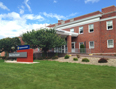Muncy Valley Hospital  215 East Water St.  Muncy, PA 17756  Phone: 570-546-8282​
  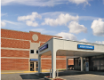 | UPMC Horizon -  Greenville  110 N. Main Street  Greenville, PA 16125  Phone: 724-588-2100 | UPMC Horizon -  Shenango Valley  2200 Memorial Drive  Farrell, PA 16121  Phone: 724-981-3500
​ | ​ | ​
UPMC Jameson​  UPMC Jameson is a full-service community hospital providing inpatient,  surgical, diagnostic, and emergency health care services for the residents  of Lawrence County and the surrounding region.  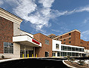UPMC Jameson  1211 Wilmington Avenue  New Castle, PA 16105  Phone: 724-658-9001 |  | Soldiers + Sailors Memorial Hospital in Wellsboro is an acute care, 67-bed community hospital which serves a rural population of over 40,000.  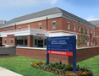Soldiers + Sailors Memorial Hospital  32-36 Central Ave.  Wellsboro, PA 16901  Phone: 570-724-7764
​ | ​ | ​
UPMC McKeesport​  UPMC McKeesport is an acute care community hospital serving the residents  of McKeesport and the historic Mon Valley.  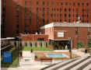UPMC McKeesport  1500 Fifth Avenue  McKeesport, PA 15132  Phone: 412-664-2000 |  | Williamsport Regional Medical Center is UPMC Susquehanna’s main acute care hospital with 207 licensed beds and 22 bassinets.  ​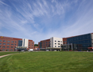Williamsport Regional Medical Center  700 High St.  Williamsport, PA 17701  Phone: 570-321-1000
​ | ​ | ​
UPMC Mercy  UPMC Mercy, in uptown Pittsburgh, offers a broad range of services and  provides compassionate care in the Catholic tradition.  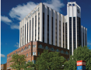UPMC Mercy  1400 Locust Street  Pittsburgh, PA 15219  Phone: 412-232-8111 |  | Western Psychiatric Institute and Clinic of UPMC​  Based in Oakland, Western Psychiatric provides people of all ages with research-based treatment for mental health and addictive disorders.​  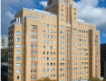Western Psychiatric Institute & Clinic  3811 O'Hara Street  Pittsburgh, PA 15213  Phone: 412-624-2100

